 | Dacorum Artistic Swimming Club  Club Kit Order Form
  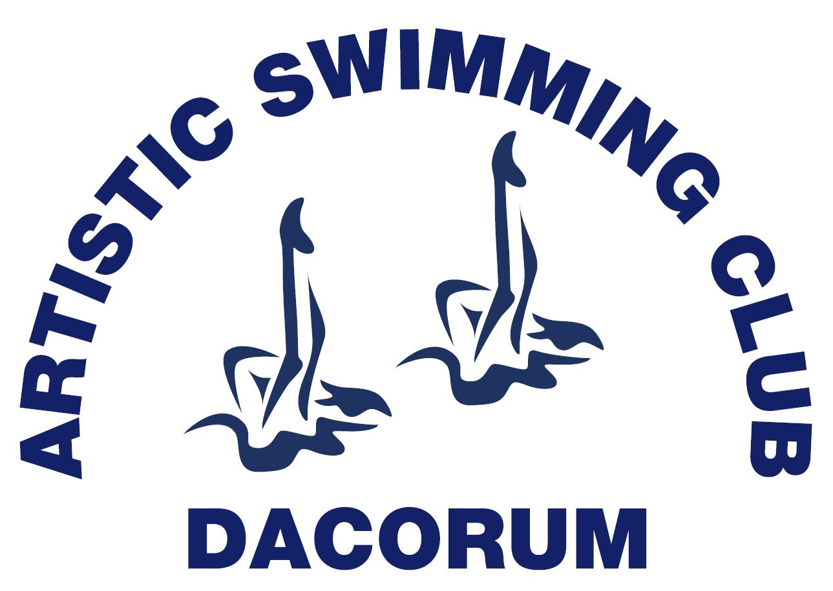

Compulsory
Swimming Costume sizes 26 – 40
Swimming Hat one size

Compulsory for Competitions
Club Blue Polo Shirt Sizes 8-14

Optional
Navy Hoodie or Jacket (limited stock available) Sizes 8-12

Pay to Dacorum Club Account - Please contact our secretary for updated prices.

Order Information:

Full Name: _____________________________
Costume size: ______________
Club Hat Yes or No: _________
Club Polo Yes or No: ________
Club Hoodie Yes or No: ______

